Right To Erasure Procedure.

Contents

Purpose 2

Scope 2

Review 2

Right To be Forgotten Procedure 3

The Procedure. 4

# Purpose

The primary purpose of the right to be forgotten is to empower individuals to protect their privacy and control over their personal data. Metropolis would aim to respect and protect individual privacy by allowing data subjects to have their data erased, thereby preventing further processing when it's no longer necessary or if consent is withdrawn.

# Scope

The procedure specified in this document applies to all information resources and assets that are owned by the company. And it’s applied to all staff, contractors, third parties, and to all other individuals or organizations who use, or support the use of the organization information processing environment. This procedure applies entirely in the organization.

# Review

The document shall be reviewed at least for each two months in case of major changes.

# Right To be Forgotten Procedure

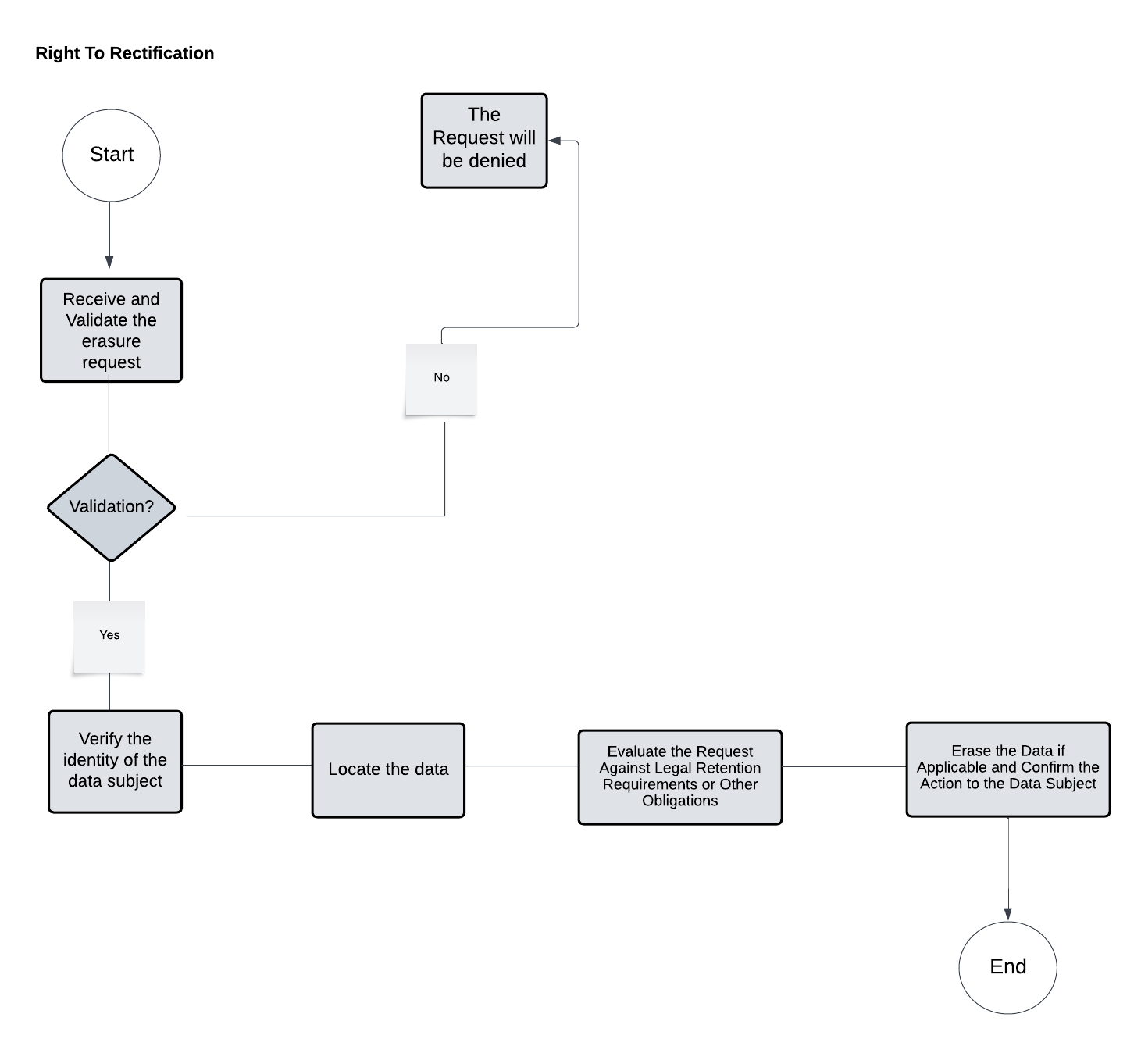

|  |  |  |
| --- | --- | --- |
| **The Activity ID** | **The Activity** | **Description on The Activity** |
| 1 | Receive and Validate the Erasure Request | Make sure the request is precise about what data is being wiped and why (if relevant). |
| 2 | Verify the Identity of the Data Subject: | Implement identity verification mechanisms (for example, demanding ID and comparing personal information).  Ascertain that the person making the request is the data subject or a legally authorized representative, which is critical for such a substantial step as data deletion. |
| 3 | Locate All Relevant Data Associated with the Subject | Conduct a comprehensive search to find all data related to the individual, ensuring nothing is overlooked. |
| 4 | Evaluate the Request Against Legal Retention Requirements or Other Obligations | Determine if the data can be legally deleted or if any retention laws apply (e.g., financial records). |
| 5 | Erase the Data if Applicable and Confirm the Action to the Data Subject | Securely erase the data, ensuring it cannot be recovered.  Notify the subject that their data has been erased or provide an explanation if it cannot be done entirely. |

## The Procedure.